**Vaibhav Lanjewar**

**2021BIT023**

**Objective:**   
Install ns-2 and get familiar with the basic commands and script structure.  
**Tasks:**

* Install ns-2 on your system.
* Run a simple wired network simulation.
* Analyze the output trace files and understand the format.

**Report:**

**Enable Developer Mode:**

* Open Developer Settings via the search (Windows + S).
* Enable "Install apps from any source..." and confirm.

**Turn on Windows Subsystem for Linux (WSL):**

* Go to "Turn Windows Features on or off" via the search.
* Check the "Windows Subsystem for Linux" option and apply.

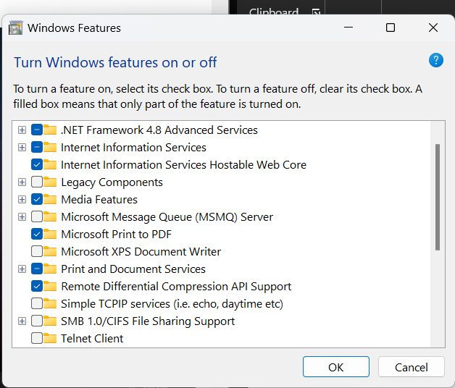

Ubuntu is installed from Microsoft store

Install NS2 and Dependencies:

sudo apt update

sudo apt-get [install](https://www.startertutorials.com/blog/step-by-step-installation-of-ns2-on-windows-10-11.html) ns2

sudo apt-get install nam

sudo apt-get install gedit

Set Working Directory:

Write and Save a TCL Program:

export DISPLAY=:0

gedit ex1.tcl

ns ex1.tcl

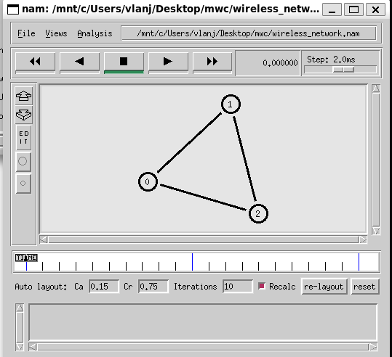

**Conclusion:**

Following these steps will install NS2 on Windows 10/11, enabling users to write and run network simulation programs. Successful completion results in a NAM window showing the output of the executed program.

This summarized process provides a clear path for installing NS2 and running simulations on a Windows environment using WSL and Ubuntu.